**Committee for Prevention of Sexual Harassment of Women :**

**Implementation year :**

ICC is implementing at college from the year 2014

**OBJECTIVES :**

**ICC established at college with following objective :**

* To prevent sexual and mental harassment of women in college campus under Prevention, Prohibition & Redressal Act, 2013 .

**ICC committee at VNCAB, Yavatmal :**

|  |  |
| --- | --- |
| **Mrs Anjali Gaharwal** | **Chairman** |
| **Shri M.V.Shete** | **Asstt. Registrar** |
| **Smt Bharti Meshram** | **Member** |
| **Smt Deepali Shinde** | **Member** |
| **Smt Mangala Pingale** | **Member** |
| **Smt. A. B. Patil** | **Member** |
| **Advocate Smt Sonali Ladekar** | **Mem. Sec. Legal Advisor** |

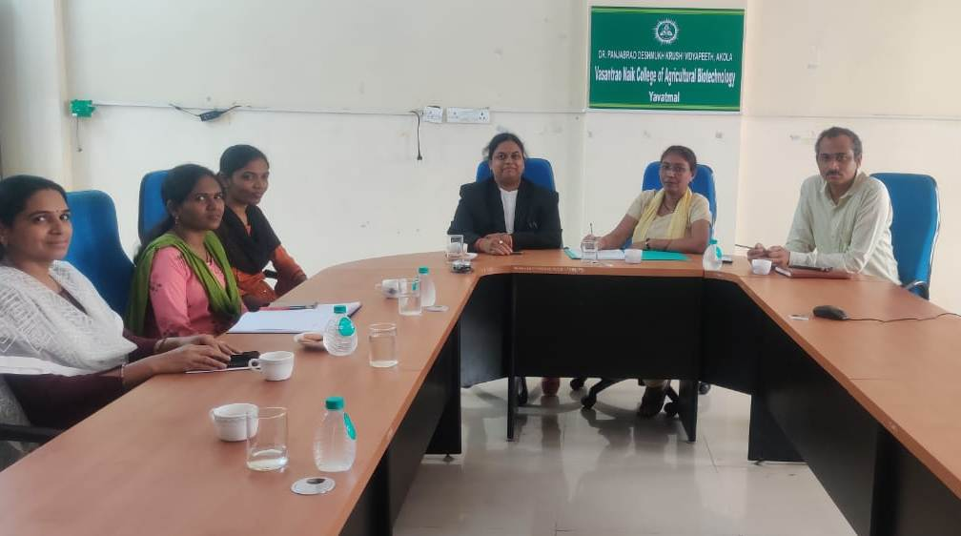

**Quarterly meeting of ICC**

|  |  |  |  |
| --- | --- | --- | --- |
| **Sr. No.** | **Date** | **Staff attended the meetings** | **Work performed** |
| 1. | 3.07.2018 | Mrs Anjali Gaharwar, Chairman  MrsNilimaPatil, Member  Dr. S. S. Wane, Member  Smt. A. B. Patil, Member  SmtSunayanaYewatkar, Member  Dr. JayashriUghade Mem. Sec. | Reconstructed the committee |
| 2. | 7.8.2018 | Dr.S.G.Bharad, Chairman  MrsNilimaPatil, Member  Dr. S. S. Wane, Member  Dr.KalyaniSarap, Member  SmtVanadana Jadhav, Member  Smt Deepali Shinde, Member  SunayanaYewatkar, Member  Anjali Gaharwar, Mem. Sec. | Decision taken to organize Health Check up camp for students |
| 3. | 29.10.2018 | Planned the programme of Health Check up camp to be organized on 30.8.2018 and allotted the work responsibilities accordingly |
| 4. | 30.11.2018 | Orientation of I semester students regarding ICC and activities of ICC. |
| 5. | 11.2.2019 | General Quarterly Meeting |
| 6. | 17.5.2019 | General Quarterly Meeting |
| 7. | 5.7.2019 | General Quarterly Meeting and formulated the students ICC at girls hostel |
| 8. | 31.9.2019 | Mrs Anjali Gaharwar, Chairman  MrsNilimaPatil, Vice chairman  Dr. S. S. Wane, Member  Dr.KalyaniSarap, Member  SmtVanadana Jadhav, Member  Smt Deepali Shinde, Member  SmtSunayanaYewatkar, Member  Smt. A. B. Patil, Mem. Sec. | Reconstructed the committee  Decision taken to organize HIV Awareness Camp for students |
| 9. | 17.10.2019 | General Meeting |
| 10. | 20.11.2019 | Mrs Anjali Gaharwar, Chairman  MrsNilimaPatil, Vice chairman  Smt Bharti Meshram, Member  Smt Deepali Shinde, Member  Smt Deepali Shinde, Member  Smt. A. B. Patil, Mem. Sec.  Shri M.V.Shete, Asstt. Registrar  SmtSonaliLadekar, Legal Advisor | Decided to reconstruct the ICC in meeting with addition of Assistant registrar and Legal advisor in the Committee. |
| 11. | 13.1.2020 | Mrs Anjali Gaharwar, Chairman  Mrs NilimaPatil, Vice chairman  Smt Bharti Meshram, Member  Smt Deepali Shinde, Member  Smt. A. B. Patil, Mem. Sec.  Shri M.V.Shete, Asstt. Reg.,M.S.  SmtSonaliLadekar, Legal Advisor | Reconstruct the committee with the order of Res. Associate Dean, VNCAB, Yavatmal |
| 12. | 18.3.2020 | General Quarterly Meeting |
| 13. | 29.6.2020 | Mrs Anjali Gaharwar, Chairman  Shri M.V.Shete, Asstt. Reg.,  Smt Bharti Meshram, Member  Smt Deepali Shinde, Member  Smt. A. B. Patil, Mem. Sec.  SmtSonaliLadekar, Legal Advisor | General Quarterly Meeting |
| 14. | 8.9.2020 | General Quarterly Meeting |
| 15. | 8.12.2020 | General Quarterly Meeting |
| 16. | 9.3.2021 | Mrs Anjali Gaharwar, Chairman  Shri M.V.Shete, Asstt. Reg.,M.SSmt Bharti Meshram, Member  Smt Deepali Shinde, Member  Smt Mangala Pingale, Member  Smt. A. B. Patil, Mem. Sec.  SmtSonaliLadekar, Legal Advisor | General Quarterly Meeting |
| 17. | 7.6.2021 | General Quarterly Meeting |
| 18. | 7.9.2021 | General Quarterly Meeting |
| 19. | 7.12.2021 | General Quarterly Meeting |
| 20. | 2.3.2022 | General Quarterly Meeting |
| 21. | 1.6.2022 | General Quarterly Meeting |
| 22. | 4.8.2022 | General Quarterly Meeting anddecision taken to organize one day workshop on laws for women |
| 23. | 21.11.2022 | General Quarterly Meeting |
| 24. | 6.3.2023 | General Quarterly Meeting |

**ACTIVITIES UNDER ICC :**

* **Regular quarterly meetings**
* **Conduction of workshops for women safety and legal laws ICC**
* **Organization of Health camp**

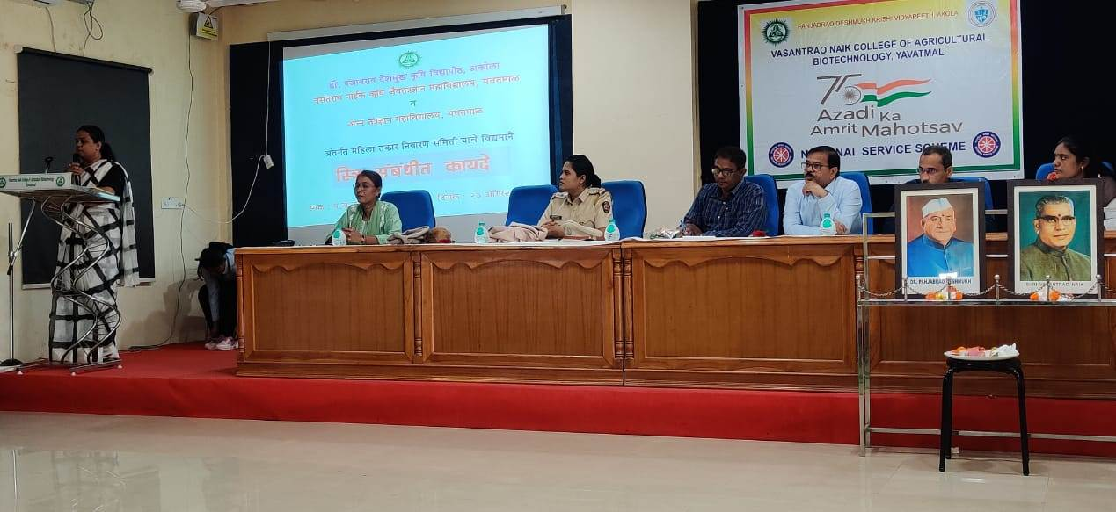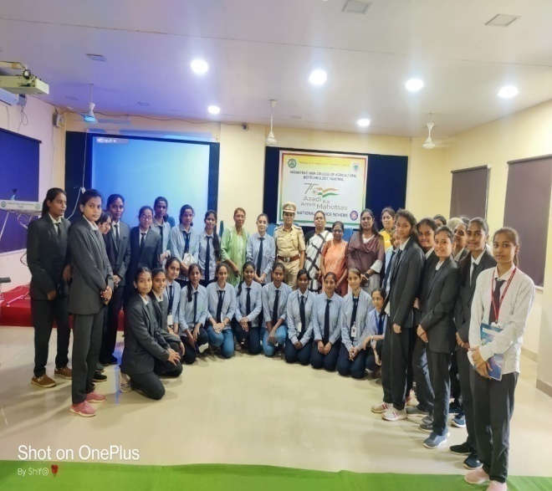

**Workshop on ‘Laws for women’**